**Solving Simple Problems in C**

**Lab 2**

**Section M**

**Submitted by:**

**Haadi-Mohammad Majeed**

**Submission Date**

**September 14, 2018**

**Date**

**September 11, 2018**

**Lab Problem**

The objective of this lab was to become familiar with the C language and learn basic skills of the terminal whilst observing integer and floating point arithmetic.

**Analysis**

The lab is broken into 5 central objectives which each consist of sub-steps. Each component of the lab could be classified as independent sections that do not require its predecessors to progress to the next.

**Design**

The first objective requests a solution to output the user’s name, followed by the course name and the date, each on its own line.

The second objective was to modify code that calculated the area of a square to then calculate the area of a rectangular prism.

The third objective had a modification of supplied code to help identify simple issues with code that would be common later down the course.

The fourth objective consisted of the outputs of many variations of similar numerals to display the results of integer arithmetic vs floating point arithmetic along with proper formatting for variable outputting.

The fifth objective requests a completion of supplied code as to output the third side of a triangle based on the geometric property of Pythagoras.

**Testing**

**Problem 1: Creating your own program**

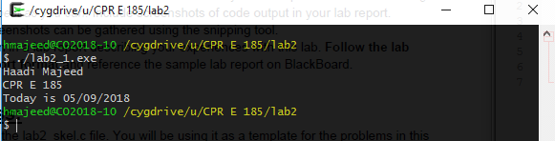

The code consisted of a single printf statement as to output all the data.

**Problem 2: A simple program with input**

Rectangle area: The code requests for 2 inputs, a base and width, multiples and outputs it as area

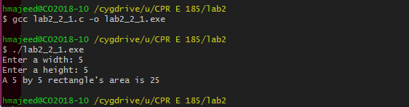

Prism area: A modification of the code from above, it obtains 3 inputs from the user and computes it as to output the volume of the rectangular prism

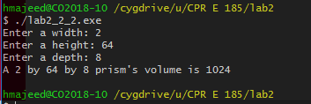

**Problem 3: Mysterious Output**

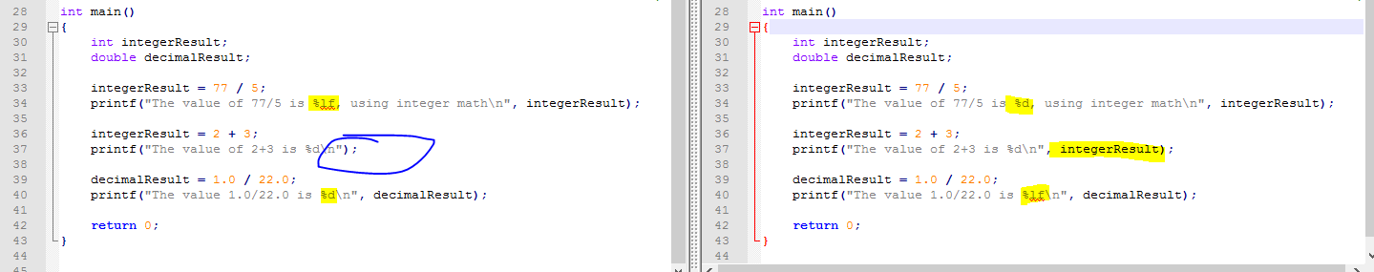

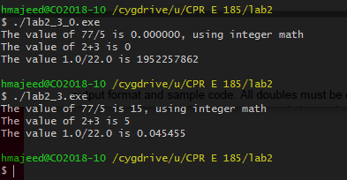

This was simply fixing errors within the code that caused the outputs to be incorrect. The code on the left side is the origin and the right has the corrected code with the differences being marked.

**Problem 4: Simple arithmetic**

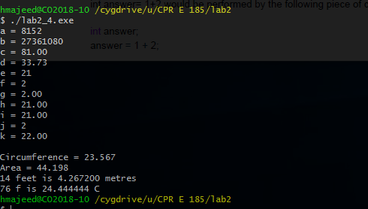

1. Integer addition, nothing special
2. The parenthesis were not necessary as order of the operations would have applied the same thing
3. The floating point solution would have been 81.4 as that would be (79+12)/5 but because it was a 5 and not 5.0 the code initiated integer division instead resulting the truncation of .4
4. Both values were floating point and as a result the answer was as well
5. (int)(22*3) = 7 which was then multiplied by 3 resulting in 21
6. (int)(22/9) which equals 2 but if done with floating point would have resulted in 2.44, if either 3 was 3.0. F was also initiated as an int.
7. Same reason for F but G was a double.
8. Follows the same reasoning for E but E was an int whereas H is a double
9. Is a double value that gets divided by an integer and then multiplied by 3.0 still resulting in 7*3
10. Same as F and G as an integer
11. Correctly computes the answer to be 22.00 due to each valuing being a double/float
12. The circumference of a circle is 2 * r * Pi, or otherwise Diameter * Pi. Thus we can get the diameter by dividing 23.567 with Pi. The area of a circle is Pi * r2 as such, the radius is needed, not diameter, so dividing by 2 will yield that result.
13. Given there is .3048 metres per foot, multiplying x number of feet by that ratio will equate to how many metres are within.
14. To convert Fahrenheit to Centigrade requires a subtraction of 32 then being divided by 1.8 which.

**Problem 5: Working with I/O – Pythagorean Theorem**

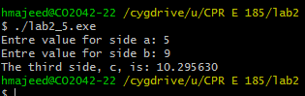

This consisted of inputting 2 values, squaring them, or multiplying it to itself, assigning it to a new variable only to output that value’s square root as the new side.

**Comments**

The lab overall was very linear and was a nice refresher to C. The code was quite easy to modify/develop for each scenario, and went flawlessly without a single error in the code. Perhaps a modification for the lab could consist of creating an area solver for any polygon based on the formula of

Perimeter * .5 * apothem

**Implementation**

**Problem 1: Creating your own program**

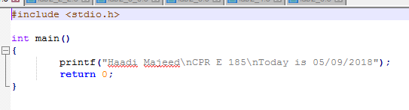

**Problem 2: A simple program with input**

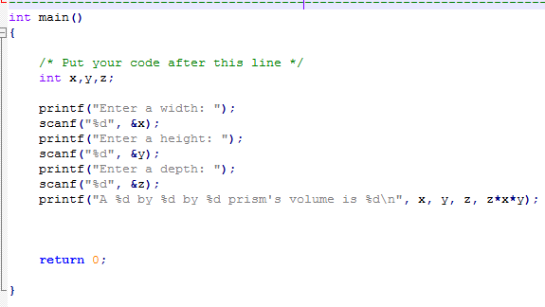

**Problem 3: Mysterious Output**

Before

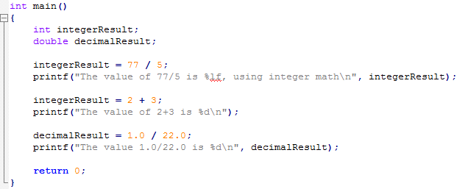

After

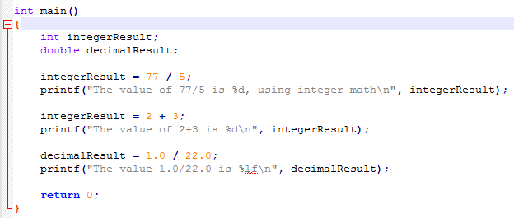

**Problem 4: Simple arithmetic**

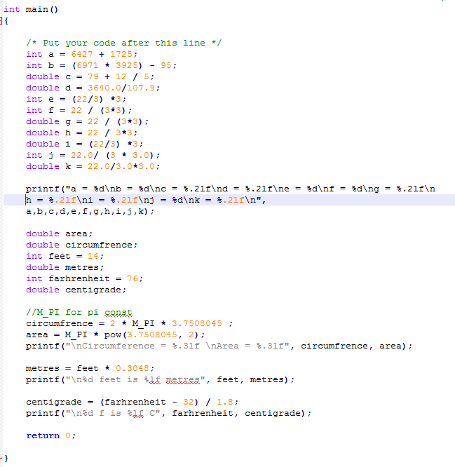

**Problem 5: Working with I/O – Pythagorean Theorem**

